2021 McCall Re-Mastered COVID Protocol

The McCall Nordic and Biathlon Ski Club Board of Directors, together with our community health partners, seek to safely execute the McCall Re-Mastered Nordic Race on a tentative date of January 23rd, 2021. The following outlines our event format regardless of the exact date, and the plan to safely disperse racers on-course, discourage congregation at the start/finish line, and implement face covering mandates.

- Racers, volunteers, spectators, and supporters will be required to wear face coverings at all times in the vicinity of the start/finish area, and aid stations.
Note: Event marketing, website, and racer packet we will kindly request participation in the event be limited to race participants and volunteers and limit spectating if possible.
- Racers will wear face coverings at the start line, and upon crossing the finish line, but may remove their mask once skiing and spaced out on the single-direction course.
- An interval start at 20 seconds will replace the traditional mass start.
- Starting line will consist of a roped chute with racer line up spots clearly marked out every 6-8’ on the snow.
- Aid stations will be reduced from three (3) to one (1) located at the lap and it will accommodate for ample spacing and be self serve. This will include multiple tables on either side of the track. Tables will be sanitized regularly, and proper PPE will be supplied to race officials manning aid stations.
- Race bibs will be handed out during packet pickup the day before in a drive through format with limited drive through options by request early the day of for out of area skiers.
- Start times will be assigned by bib number and communicated via email and listed on website and within racer packets.
- No Awards Ceremony will be held following the event and racers and spectators will be encouraged to leave the area as quickly as possible.
- No food or beverage will be offered pre- or post-race.
- Race registration will be cut off on Thursday, January 21 - No Day of Registration
- We will cap the event participation at 100 racers.
- All volunteers will be supplied with adequate PPE to include, gloves, face coverings, face shields if available, and hand sanitizer.
- If available we will rent hand wash stations in conjunction with Portable toilets. Hand sanitizer stations will also be available for participants.

Face Coverings
Face coverings will be worn by ALL persons at the event in public areas. These areas include the start/finish area, parking lot, and aid station. Racers will wear face coverings during the race start, but may remove them once spaced out on-course. Upon crossing the finish line, racers will re-cover their faces until they are either spaced out back on-course or away from the start/finish area upon completion of the race. Tables at aid stations will be spaced far enough off the trail to accommodate racers skiing through opting out of aid.

Race Cap & Packet Pick-Up
Event will be capped at 100 participants. Historically we have rarely had over 100 participants and feel we can safely spread out and manage up to 100 participants based on past experience and protocols being put in place.
Packet pick-up will take place in a drive through format outside the day before and only upon request in the same format early the morning of to accommodate out of area participants.

Interval Start
An interval start at a frequency of 20 seconds will replace the traditional mass start. Racers will enter the course via a roped-off shoot with 6’-8’ spacing clearly marked in the snow. We will outline in detail the start format, racer start times based on bib number, and expectations via email communication and both on the website and within racer packets.

Drafting
Drafting will be discouraged during the 2021 event to further discourage congregation of participants and close contact.

Aid Stations
Aid stations will be limited to one at the lap and it will be set up to accommodate for ample spacing between racers and volunteers. Two to three tables will be set up on each side of the track with ample room for skiers to safely ski through opting out of aid. Aid will be self serve and each table will offer the same amenities to discourage congregation around a single table. Tables will be sanitized as frequently as possible by volunteers.

Awards Ceremony
The Awards Ceremony and raffle drawing will be cancelled. Results will not be posted in hard copy but rather via the website. Winners of each age category will be mailed their prizes following the event. This will further discourage congregation post race around the start/finish area, or at the traditional results board

Food and Beverage
The traditional post-race meal and beverage options will not be offered to further discourage congregation around the start/finish area. If the race chooses to host aid stations, food offerings will be in individually wrapped packages spaced to allow for racers to only touch the aid item they wish to use. Table surfaces will be sanitized frequently using CDC approved cleaning solutions.

Traffic Flow
Public areas, including the drive-through packet pick up area, the start/finish area, and parking areas will be clearly signed to assist participants, volunteers, and supporters to move efficiently around the event. Preventing congestion in high-traffic areas is imperative to support adequate spacing.

The safety protocol outlined above was designed by the McCall Nordic and Biathlon Ski Club Board of Directors in the interest of safely hosting the 2021 McCall Re-Mastered Nordic Race. The Board wishes to acknowledge the unique constraints posed by orchestrating an event during the COVID-19 pandemic. By carefully implementing the safety measures detailed in this document, and working together with local healthcare partners, we feel that we can responsibly host the 2021 McCall Re-Mastered Nordic Race.

Molly Eimers
&
The McCall Nordic & Biathlon Ski Club Board of Directors
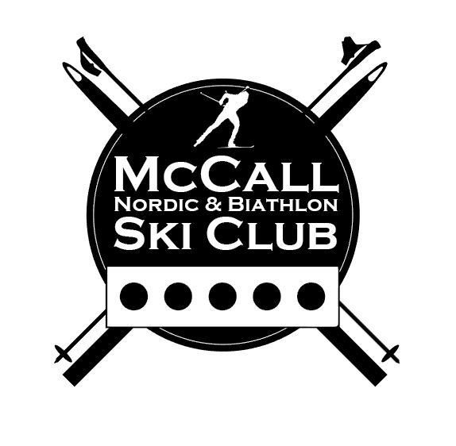
Tom Bates, Kurt Wolf, Paul Klasner, Bill Thomas

